**CONSULTA TU ENVIO – ANGULAR**

**Objective**: converting “Consulta Tu Envio” from ASPX application to Angular application.

**What is it**: a web page who show customers and businesses their send to ICP warehouse

**Technical Specification**: the application is hosted on the IIS of WSERVER11 (the physical location is \\wserver11\web\www_WebConsultaEnvio_A2). This subsite it’s not called directly, but it is called from a redirect of the original location of project:

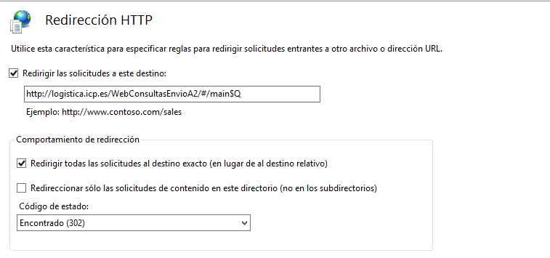

Database data are obtained through a web service, which is hosted on WSERVER11 as well (<https://logistica.icp.es/WS4WApps/api/WebICP>), with a querystring which contains the information to extract.

Is it possible to specify a different web service location, for test purposes, through the “environment.ts” file.

The source files are hosted on GIT:

**APPLICATION**

The application is developed to accomodate every suppliers. There’s translation available in this four different language: Spanish, English, Portuguese and Italian.

The application will be showed like this:

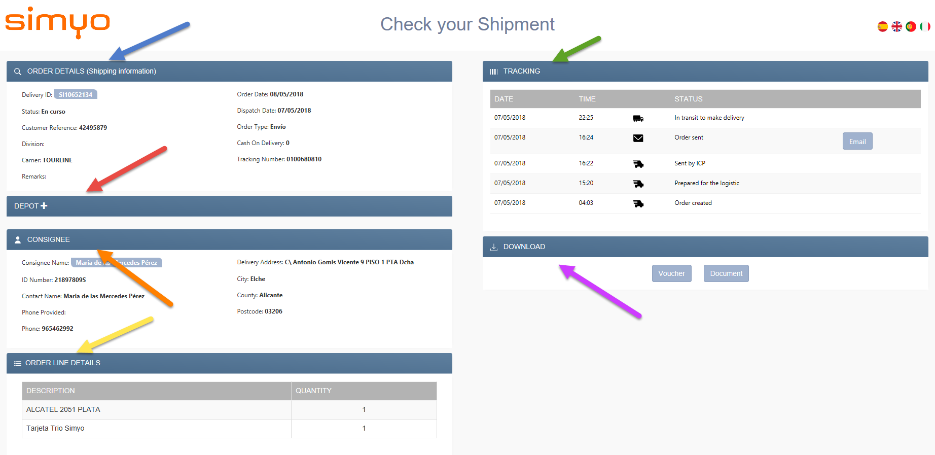

**Blue Arrow**: shows the details of the order. Is it possible that, through the querystring, it came an Orden instead of a Pedido. In this case, this section will be showed as “DETALLE ORDEN” instead of “DETALLE PEDIDO”, and it will show some different data.

**Red Arrow**: this shows the Depot (or Delegación De Transporte). This section not always is shown, it depends on the pedido. If there’s not a Depot, this will not be shown.

**Orange Arrow**: the customer data.

**Yellow Arrow:** shows the items sent by the customer. Like the depot, if there is any item, this section will not be showed.

**Green Arrow:** shows the tracking of the data. It is possible that, in a particular state, the track row brings with it an email. In this case it will be show a button to open the email, so the customer could read it without leave the application.

**Purple Arrow:** Set available invoice and/or comprobante to the customer. Like in the Depot case (red arrow), it is possible that neither are available. If so, this section will not be showed. Invoice is typically a .PDF, while the comprobante is most of the case an image.

Logo changes dynamically, based on the supplier involved.